Smart Waste Management System using IoT


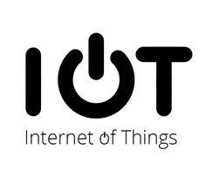

BY-
K.DEEKSHA
M.M.S.SAHITHI
K.R.SIVANI

ABSTRACT

In the present day scenario, many times we see that the garbage bins or dust bins are placed at public places in the cities overflowing due to increase in the waste everyday. It creates unhygienic condition for the people and creates bad smell around the surroundings this leads in spreading some deadly diseases & human illness, to avoid such a situation we are planning to design “Smart Waste Management System” using iot. In this system there are multiple dustbins located throughout the city or the campus, these dustbins are provided with low cost embedded device which helps in tracking the level of the garbage bins and an unique id will be provided to each dustbin in the city so that it can easily identify which garbage bin is full. When the level reaches the threshold limit, the device will transmit the level along with the unique ID provided. These details can be accessed by the oncern authorities from their place with the help of internet and an immediate action can be made to clean the dustbins.

INTRODUCTION
Things that are connected to internet and sometimes these devices can be controlled from the internet is commonly called as Internet of Things. The IOT is a concept in which surrounding objects are connected through wired and wireless networks without user intervention. In the field of IOT, the objects communicate and exchange information to provide advanced intelligent services for users. Owing to the recent advances in mobile devices equipped with various sensors and communication modules, together with communication network technologies such as wi-fi and LTE, the iot has gained considerable academic interests. Owing to the characteristics and merits of the iot services, waste management has also become a significant issue industry and government as major iot application fields. An indiscriminate and illegal discharge of waste, and inefficient waste management policies have caused serious environmental problems. In our system, the smart dustbins are connected to the internet to get the real time information of the smart bins. Managing the smart bins by monitoring the status of it and accordingly taking the decision. This waste is further picked up by the municipal corporations to finally dump it in dumping areas and landfill’s. In our system the smart bin/s are connected to the internet to get the real time information of the smart dustbins. These dustbins are interfaced with node mcu and ultrasonic sensors. Where the ultrasonic sensor detects the level of the dust in the dustbins and sends the signal to the node mcu the same signal is sent to the application and it is received. The data is received, analysed, processed which displays the status of the dust bins on the application of authorized person mobile. And finally the garbage trucks collect the garbage from the completely full dustbin and dispose it.

LITERATURE SURVEY

Seven reports were reviewed in detail for the literature review, with the majority of these providing some evidence to support the theory that the introduction of waste collections is associated with the reduction in waste arisings. The following text should be reviewed with consideration given to the fact that these studies were not specifically designed to access the impact of waste collections on at source food waste reduction. Therefore evidence is taken from these reports to be used in different context from that in which it was collected. For example, a common theme across all the reports was the fact that where a reduction in food waste arisings had been observed, ther was limited data to confirm how much food waste has simultaneously been diverted from the residual waste stream to home compositing and how much was a result of at source waste prevention behavior. A number of the reports the diversion of waste to home compositing, as a contributor to waste reduction, as this reduced the waste food waste arisings collected at the kerbside. Overall the reports demonstrate that while there is some evidence to support the theory that implementing a waste collection can lead to an overall reduction in collected waste, there is currently no significant evidence to demonstrate to what extent this is due to prevention at source as opposed to diversion to home compositing. A number of the reports support the need for further research in this area.

BLOCK DIAGRAM

MOBILE APPLICATIONS

CLOUD

ESP8266


DUSTBIN WITH ULTASONIC SENSOR
POWER SUPPLY

WORKING
This project Smart Waste Management using IOT is a very innovative system which will help to keep the cities clean. This system monitors the garbage bins and informs about the level of the garbage collected in the garbage bins via mobile application. For this system ultrasonic sensors placed over the bins to detect the garbage level and compare it with the garbage bins depth. The system makes use of ESP8266 for sending data. An application is built to show the status to the user monitoring it. An application gives a view of the garbage bins and highlights the garbage collected in color in order to show the level of the garbage collected. Thus the system helps to keep the city clean by informing about the garbage levels to the personal. The authorized person receives the indication and informs to the concerned person responsible for collection of garbage bins. Here, first the code is written addressing the solution to the current problem. Ultrasonic sensor is attached at the top of the dustbin and it is connected to ESP8266 . When the code is uploaded the range of ultrasonic sensor can been seen. When the dust inside the bin is increasing the ultrasonic distance gradually decreases and these values are sent and stored in iot platform . Using node-red application the nodes are connected according to need and link is copied for user interface. The garbage values are shown in user interface. An MIT application is used for interacting it with the mobile phones. In mit we design gui that has to be appeared in phone,after completion the barcode is scanned and values are obtained in mobile phone. Atlast, user convenience has been enhanced with IoT.

Code in Arduino
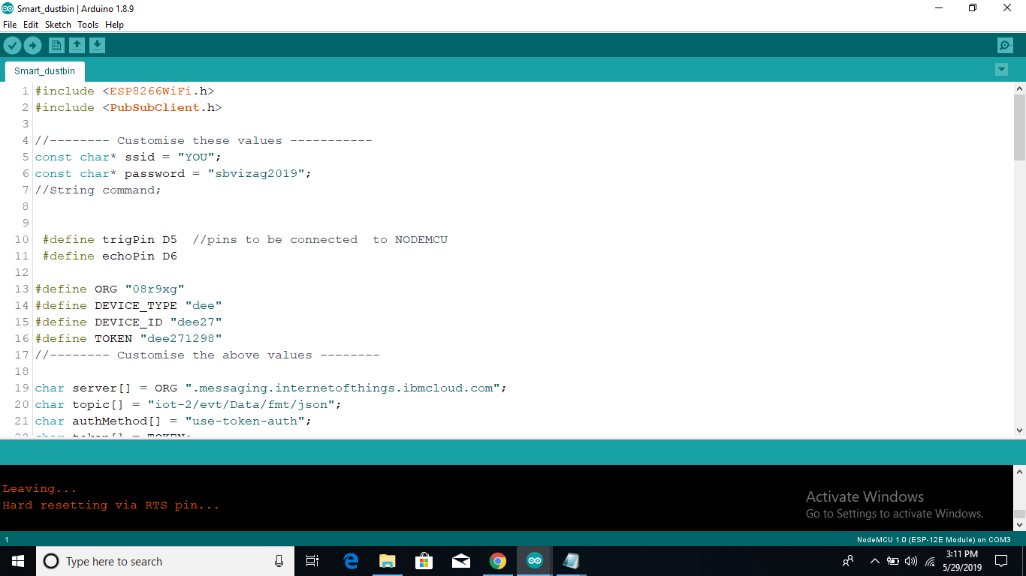
Ultrasonic sensor connections with ESP82666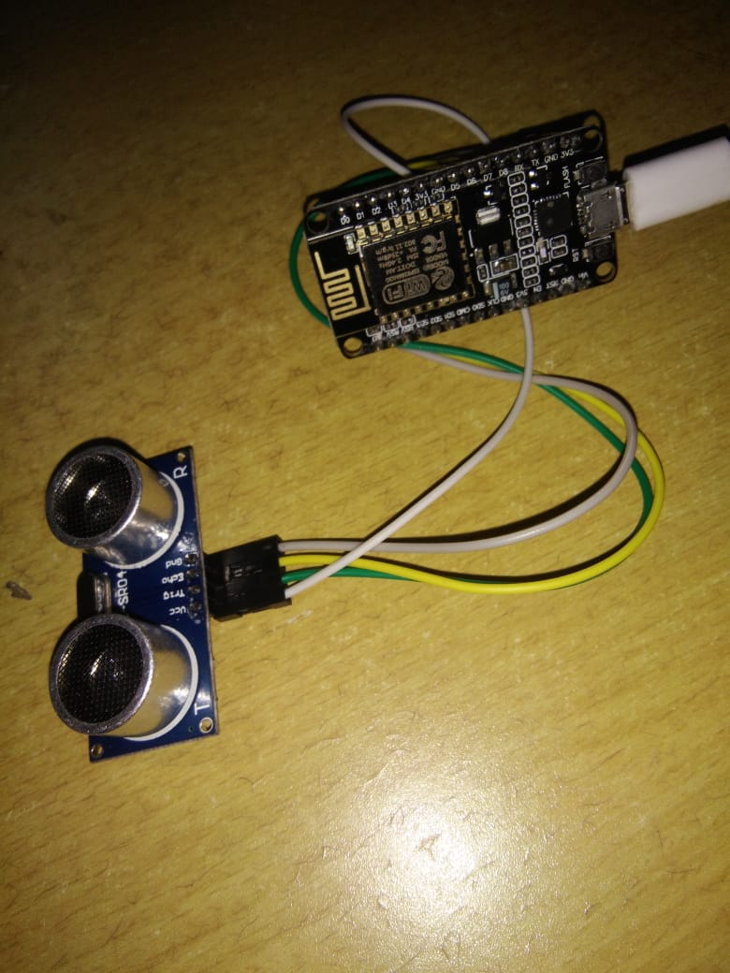
Output of code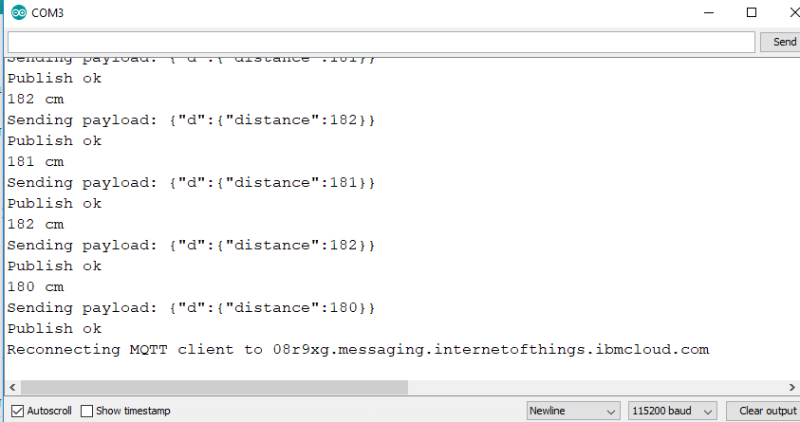
Node-red application
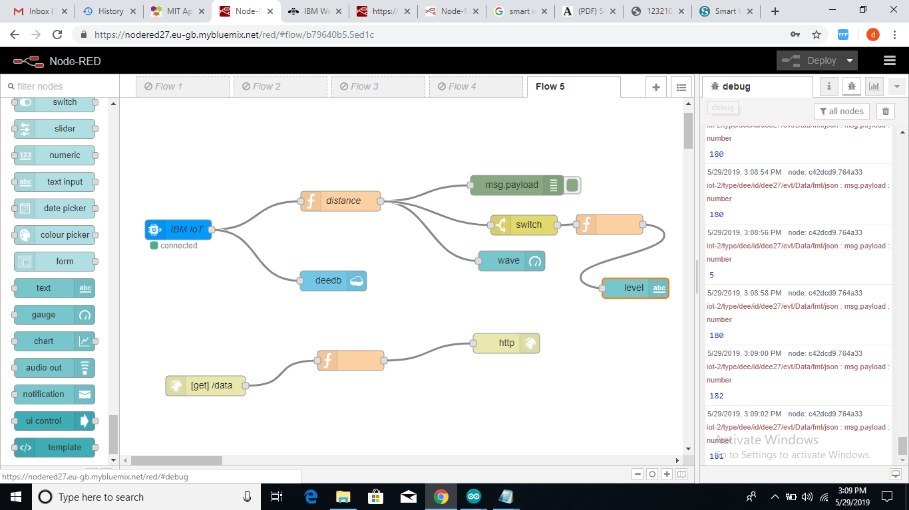

MIT application
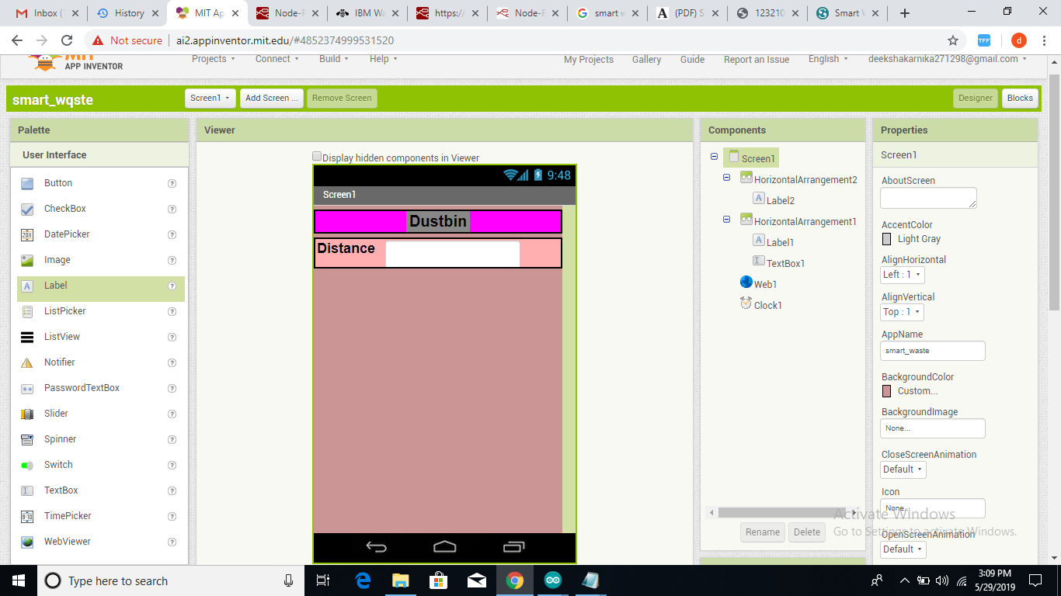
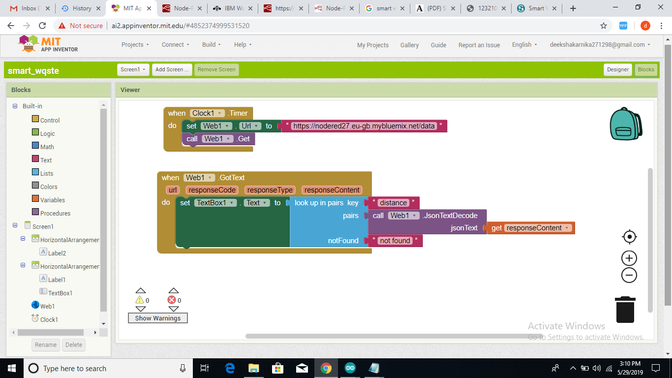

Mobile
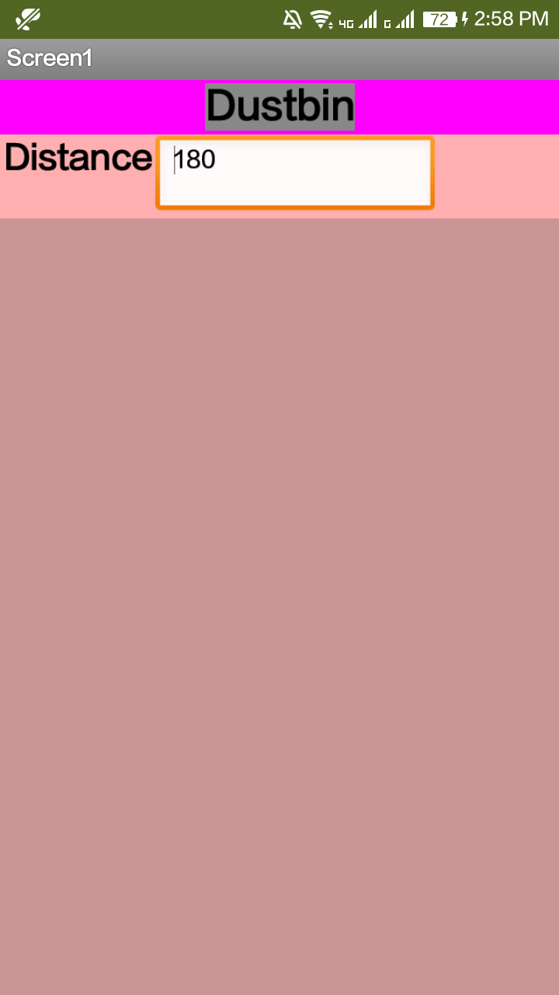

HARDWARE REQUIREMENTS
We use mainly 2 hardware components for this system. They are Ultrasonic sensor and ESP8266.

ULTRASONIC SENSOR
Ultrasonic sensor is a 4 pin module, whose pin names are Vcc, Trigger, Echo and Ground respectively. This sensor is a very popular sensor used in many applications where measuring distance or sensing objects are required. The module has two eyes like projects in the front which forms the Ultrasonic transmitter and Receiver. The sensor works with the simple high school formula that
Distance = Speed × Time
The Ultrasonic transmitter transmits an ultrasonic wave, this wave travels in air and when it gets objected by any material it gets reflected back toward the sensor this reflected wave is observed by the Ultrasonic receiver module.
Now, to calculate the distance using the above formulae, we should know the Speed and time. Since we are using the Ultrasonic wave we know the universal speed of US wave at room conditions which is 330m/s. The circuitry inbuilt on the module will calculate the time taken for the US wave to come back and turns on the echo pin high for that same particular amount of time, this way we can also know the time taken. Now simply calculate the distance using a microcontroller or microprocessorHz.

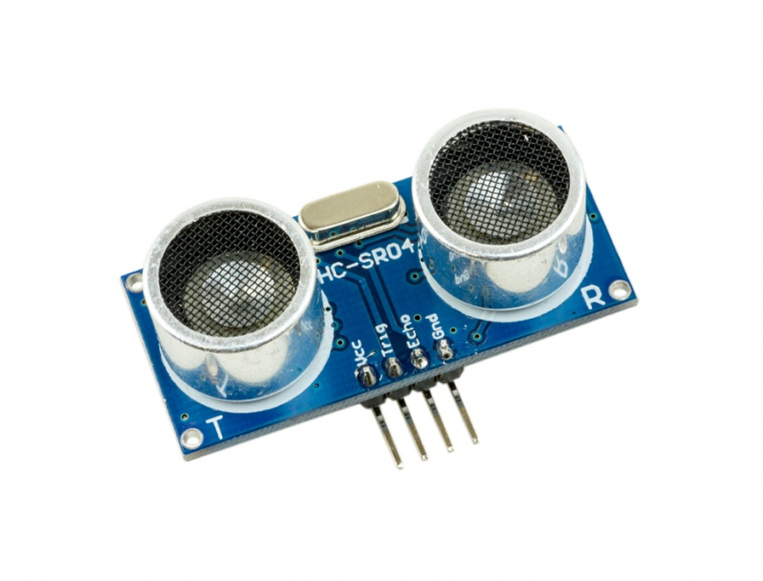
Sensor Features
Operating voltage: +5V
Theoretical Measuring Distance: 2cm to 450cm
Practical Measuring Distance: 2cm to 80cm
Accuracy: 3mm
Measuring angle covered: <15°
Operating Current: <15mA
Operating Frequency: 40Hz

ESP8266
NodeMCU is an open source IoT platform. Which includes firmware which runs on the ESP8266 Wi-Fi Module from Espressif Systems,and hardware which is based on the ESP-12 module. The term “NodeMCU” by default refers to the firmware rather than the dev kits. NodeMCU firmware was developed so that AT commands can be replaced with Lua scripting making the life of developers easier. So it would be redundant to use AT commands again inNodeMCU.
The ESP8266 is a low-cost Wi-Fi chip with full TCP/IP stack and microcontroller capability produced by Shanghai-based Chinese manufacturer, Espressif.
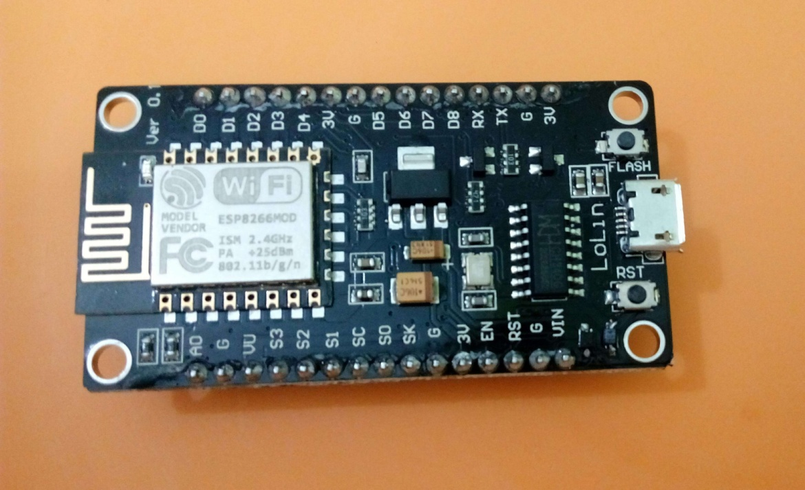

Coding

INTERFACING ESP8266 WITH ULTRASONIC SENSOR

The Ultrasonic sensor has 4 pins named Vcc, Gnd, Echo and Trig. These 4 pins are connected to ESP8266. Vcc & Gnd in ultrasonic is connected to Vin Gnd in ESP8266, Echo and Trig pin are connected to any of the GPIO pins. The ESP8266 is then connected to PC with the help of USB cable. Power supply is provided with USB cable.

ARDUINO SOFTWARE CODE

#include<ESP8266WiFi.h>
#include<PubSubClient.h>

//--------Customisethesevalues-----------
constchar*ssid="YOU";
constchar*password="sbvizag2019";
//Stringcommand;

#definetrigPinD5//pinstobeconnectedtoNODEMCU
#defineechoPinD6

#defineORG"08r9xg"
#defineDEVICE_TYPE"dee"
#defineDEVICE_ID"dee27"
#defineTOKEN"dee271298"
//--------Customisetheabovevalues--------

charserver[]=ORG".messaging.internetofthings.ibmcloud.com";
chartopic[]="iot-2/evt/Data/fmt/json";
charauthMethod[]="use-token-auth";
chartoken[]=TOKEN;
charclientId[]="d:"ORG":"DEVICE_TYPE":"DEVICE_ID;

WiFiClientwifiClient;
PubSubClientclient(server,1883,wifiClient);

voidsetup(){
pinMode(trigPin,OUTPUT);
pinMode(echoPin,INPUT);

Serial.print("UltrasonicSensorStarting!!!");
Serial.println("");
Serial.begin(115200);
Serial.println();
Serial.print("Connectingto");
Serial.print(ssid);
WiFi.begin(ssid,password);
while(WiFi.status()!=WL_CONNECTED){
delay(500);
Serial.print(".");
}
Serial.println("");

Serial.print("WiFiconnected,IPaddress:");
Serial.println(WiFi.localIP());
}

voidloop(){
intduration,distance;
digitalWrite(trigPin,HIGH);
delay(1000);
digitalWrite(trigPin,LOW);
duration=pulseIn(echoPin,HIGH);
distance=(duration/2)*0.0343;//time*speedofsound(0.0343cm/microsec)
Serial.print(distance);
Serial.println("cm");
delay(1000);
PublishData(distance);
if(!client.loop()){
mqttConnect();
}
delay(100);
}
voidmqttConnect(){
if(!client.connected()){
Serial.print("ReconnectingMQTTclientto");Serial.println(server);
while(!client.connect(clientId,authMethod,token)){
Serial.print(".");
delay(500);
}
initManagedDevice();
Serial.println();
}
}
voidinitManagedDevice(){
if(client.subscribe(topic)){
Serial.println("subscribetocmdOK");
}else{
Serial.println("subscribetocmdFAILED");
}
}

voidPublishData(intdistance){
if(!!!client.connected()){
Serial.print("Reconnectingclientto");
Serial.println(server);
while(!!!client.connect(clientId,authMethod,token)){
Serial.print(".");
delay(500);
}
Serial.println();
}
Stringpayload="{\"d\":{\"distance\":";
payload+=distance;
payload+="}}";
Serial.print("Sendingpayload:");
Serial.println(payload);
if(client.publish(topic,(char*)payload.c_str())){
Serial.println("Publishok");
}else{
Serial.println("Publishfailed");
}
}

NODE-RED APPLICATION
Node-RED is a programming tool for wiring together hardware devices, APIs and online services. Primarily, it is a visual tool designed for the Internet of Things, but it can also be used for other applications to very quickly assemble flows of various services.
Node-RED is open source and was originally created by the IBM Emerging Technology organisation. It is included in IBM’s Bluemix (a Platform-as-a-Service or PaaS) IoT starter application package. Node-RED can also be deployed separately using the Node.js application. At present, Node-RED is a JS Foundation project.
Node-RED enables users to stitch together Web services and hardware by replacing common low-level coding tasks (like a simple service talking to a serial port), and this can be done with a visual drag-drop interface. Various components in Node-RED are connected together to create a flow. Most of the code needed is created automatic devices.

MIT APPLICATION
MIT App Inventor helps people around the world build mobile apps that can make a difference for their families, schools, and communities— even if they've never programmed before.
MIT App Inventor is changing how the world creates apps and how kids learn about mobile computing. Over 400,000 active inventors a month from 195 countries have created more than 22 million apps.
MIT App Inventor now brings that same power and simplicity of app creation to the Internet of Things (IoT) and the universe of connected devices.

LIMITATIONS OF EXISTING SYSTEM

- Time consuming and less effective : Trucks go and empty containers whether they are full or not.
- High costs.
- Unhygienic Environment .
- Bad smell spreads and may cause illness to human beings.
- More traffic and noise.

ADVANTAGES OF PROPOSED SYSTEM
- Real time information about the status of the dustbin.
- Deployment of dustbin based on actual needs.
- Cost reduction and resource optimization.
- Improves environment quality.
- Cleaner cities.
- Effective usage of dustbins.

CONCLUSION

We have implemented real time waste management system by using smart dustbins to check the level of the dustbin. In this system the information of all smart dustbins can be accessed from anywhere and anytime by the concern person and he can take the decision accordingly. By implementing this proposed systemthe cost reduction, resource optimization, effective usage of smart dustbins can be done. This system indirectly reducing traffic in the city. In major cities the garbage collection vehicle visits the area everyday twice or thrice depends on the population of the particular area and sometimes these dustbins may not be full. Our system will inform the status of each and every dustbin in real time so that the concerned authority can send the garbage collection vehicle only when the dustbin is full. The scope for the future work is this system can be implemented with time stamp in which real time clock shown to the concern person at what time dustbin is full and at what time the waste is collected from the smart dustbins.

